**PIEP – ExtractionPS**

**User Guide**

## VERSIONING AND CONTROL VALIDATION

VERSIONING HISTORY

|  |  |  |  |
| --- | --- | --- | --- |
| Version | AUTHOR | REVISION | Date |
| 1.0 | RCAS (CGI) | Creation | 17/12/2019 |
| 1.1 | RCAS (CGI) | Implementation of a log system and exception management | 01/29/2020 |
| 1.2 | RCAS (CGI) | Addition of the exception message generated by the script in the logs | 03/10/2020 |
| 1.3 | RCAS (CGI) | Management of long periods of time + split 1 file by tag + compression | 03/16/2020 |
| 1.4 | RCAS (CGI) | Management of non-existent tags + simplification and harmonization of logs | 04/03/2020 |
| 1.5 | RCAS (CGI) | Translate the code in english + management of compression choice + automatic version using parameters. | 28/04/2020 |
| 1.6 | RCAS(CGI) | New parameter to choose localtime or utc timestamp. | 08/06/2020 |
| 1.7 | RCAS(CGI) | Update 2 parameters from string to switch | 17/06/2020 |
| 1.8 | RCAS(CGI) | Prerequisite review | 17/08/2020 |
| 1.9 | RCAS(CGI) | Add recurrent extraction process | 19/07/2021 |
| 2.0 | MSAU (CGI) | Add option for no empty files generated | 23/05/2022 |

VALIDATION

|  |  |  |
| --- | --- | --- |
| Version | Name | Date |
| 1.5 |  |  |
|  |  |  |

## DOCUMENT CONTENT

1. VERSIONING AND CONTROL VALIDATION 2

2. DOCUMENT CONTENT 3

3. SCRIPT DESCRIPTION 4

3.1 Objective 4

3.2 Prerequisite 4

4. USER GUIDE 5

4.1 Prepare the input file 5

4.2 Configure 01-ExtractionPS.bat 5

4.3 Run ExtractionPS 6

4.4 Clean the application 6

4.5 Alternative mode : Recurrent extraction 6

## SCRIPT DESCRIPTION

### Objective

**The purpose of ExtractionPS is to extract data from tags PI on a chosen period into output files**.

The user provide the server name, the start time/end time of the extraction, and a list of tags.

### Prerequisite

* Microsoft Powershell (1.0 or later).
* Package PI SMT 2018 or later.
* DO NOT run the script on production environnement.

## USER GUIDE

Copy the folder ExtractionPS in your local machine/server.

### 4.1 Prepare the input file

Get a list of the tags you want to extract data. Copy the list on the folder “.\input\Points.txt”, one tag per line. Example :

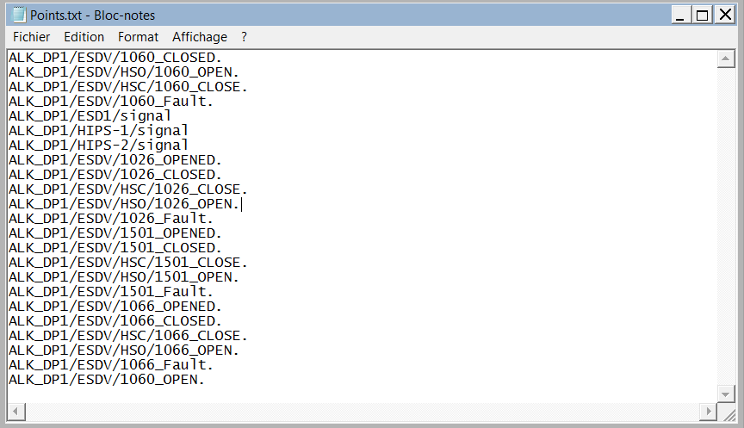

### 4.2 Configure 01-ExtractionPS.bat

Edit the file “.\script\01-ExtractionPS.bat”.

*cd /d %~dp0..*

*powershell.exe -file .\ExtractionPS.ps1 -PIServerHost "SERVER_NAME" -startTime "yyyy-MM-ddThh:mm:ss*

*" -endTime "yyyy-MM-ddThh:mm:ss" –useUTC -doCompress -doCompressAll -noEmptyFile*

Adjust the following parameters :

* **PIServerHost** : Name of the PI Server to extract tags (exemple : PI-CENTER-HQ)
* **starttime** : Start time of extraction (Format : yyyy-MM-ddThh:mm:ss)
* **endtime** : End time of extraction (Format : yyyy-MM-ddThh:mm:ss)
* **useUTC** : Option to extract the data on UTC format (local as default)
* **doCompress** : Option to compress the file to zip format after extraction.
* **doCompressAll** : Option to compress all the files to one zip at the end of the extraction.
* **noEmptyFile** : Option to generate only files which are not empty.

Then save the modifications and close the file.

### 4.3 Run ExtractionPS

**Run the script 01-ExtractionPS.bat** (**do not** run it as administrator).

You should have the following window opened. Let the program extract the data.

The logs are stored in the “.\logs” directory.

When the line “Press Enter to quit ExtractionPS” appear, press Enter to quit.

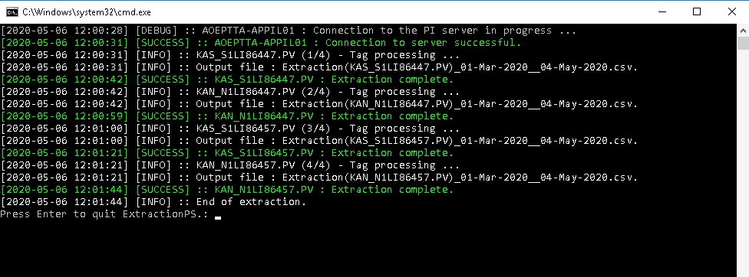

### 4.4 Clean the application

When the extraction is finished, collect your data files in the “\output” directory.

You can run the script ".\script\02-CleanOutputDirectory.bat" to delete automatically the output files for a new extraction.

### Alternative mode : Recurrent extraction

If you want to install ExtractionPS and use it to extract the last 10 minutes of data each 10 minutes, you can create a schedule task to run the script ".\script\03-RecurrentExtractionPS.bat".

Edit the script this way :

*cd /d %~dp0..*

*powershell.exe -ExecutionPolicy bypass -file ".\RecurrentExtractionPS.ps1" -PIServerHost "[PISERVERHOST]" -output "[OUTPUTPATH]" -noEmptyFile -doCompressAll -doCompress*

*cd script*

NB : This script will run the *".\RecurrentExtractionPS.ps1”* which will calculate the starttime and endtime regarding the current time, and it will run the original code with theses parameters.s